NA, Woon-gyu/NA, Un-gyu (October 27, 1902--August 9, 1937)

Na Woon-gyu was an actor, writer and filmmaker in colonial Korea. He has been called Korea’s first movie star, and is credited with having laid the foundations for a national Korean cinema with his legendary 1926 film *Arirang*. Drawing on the popular genre of *shinpa* melodrama, *Arirang* depicted a madman who kills a Japanese sympathizer while in a delusional state. The film industry in colonial Korea was dominated and carefully regulated by the Japanese. The trope of madness and the conventions of *shinpa*, which pitted the rich and strong against the poor and weak, provided *Arirang* with an alibi for the purpose of avoiding censorship. But madness could also symbolize the loss of country, and the melodramatic pattern lent itself to allegories of colonial oppression. Korean audiences celebrated the film as an expression of nationalism and anti-Japanese resistance. Na himself had been jailed for independence movement activities, and went on to make a series of similarly nationalist films, founding his own production company in 1927. Although he is also thought to have made conciliatory films as censorship tightened in the 1930s, he is remembered as a voice of nationalism and resistance. He was one of the most prolific Korean filmmakers of the colonial period, but all of his films are now presumed lost.

**Selected works:**

*Arirang* (1926, lost)

*Looking for Love* (*Sarang ŭl ch'ajasŏ*, 1928, lost)

As actor: *A Ferryboat that Has No Owner* (*Imja ŏmnŭn narutpae*, 1932, lost)

**Further reading:**

Lee, H. (2000) *Contemporary Korean Cinema: Identity, Culture and Politics*. Manchester: Manchester University Press.

Min, E.; Joo, J.; Kwak, H. (2003) *Korean Film: History, Resistance, and Democratic Imagination*. Westport, CT: Praeger.

Kim, S.(2011) “Cartography of Catastrophe: Pre-Colonial Surveys, Post-Colonial Vampires, and the Plight of Korean Modernity” in *The Journal of Korean Studies* 16 (2).

Paratextual material:

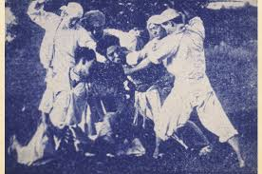

A still from the film *Arirang*, Na Woon-gyu at center

(from http://www.47news.jp/47topics/arirang/1.html)

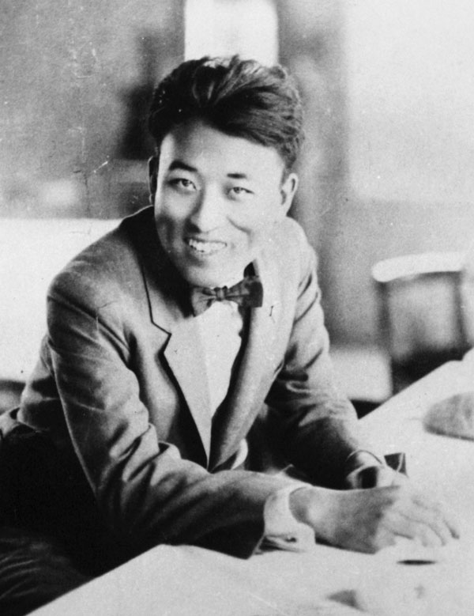

Na Woon-gyu

Ryan Cook

Harvard University